In seeking to optimize or better the given credit risk model of the Bank of Queensland (BoQ) using Generalised Linear Models (GLMs), tests utilizing Random Forests, Lasso and StepAIC techniques were conducted to find maximum efficiency rates to classify loan defaults. Typical struggles of the current state of the model used include rigidity and bias as models focus more on customers of accepted loans rather than those of rejected loans.

We saw an improvement of $22525 profit over the baseline.

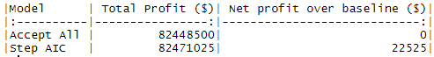

As per credit risk modelling experts of SAS, elements of a good credit risk model cover speed, precision, confidence (Akhadov, Rogers & Filipenkov, 2018). Speed of credit decisions matter as competition means a lag of several minutes means a world of difference. The precision determines the extent of accurate credit decisions that maximize revenue and minimize defaults. A good measure of confidence is the balance between risk aversion and business development in a model to allow more creditworthy customers as well as ensuring the validity of models through transparency and rigor in credit scoring.

In using the StepAIC method, the data was cleaned, explored and variables of significant weight based on research and heuristics include payment terms, loan subgrade, annual income, loan purpose, inquiries in the past six months, public records, revolving utility, employment length, and credit length. Lasso regression and Random Forests methods were used in comparison and were found to be less efficient than StepAIC.

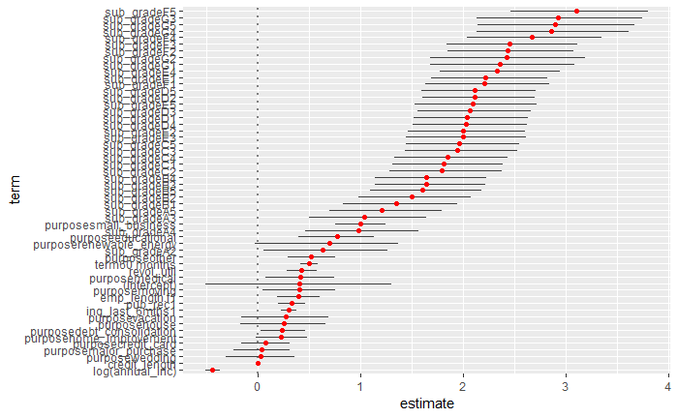

Looking at the confidence intervals of our chosen method, we observe that the subgrade affects the model by increasing the likelihood of default as we transition down the ranks, as expected. We notice high variability in the purpose of loans, suggesting that other factors play a more important role in the repayment of loans. The only factor which reduces default chance is annual income. Additionally, it appears the intercept has a large variation.

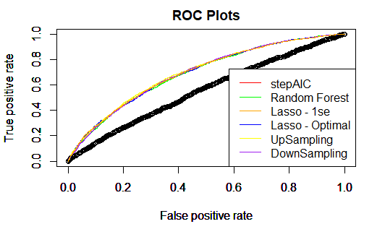

The model gives us an accuracy of approximately 80% of predicting that a customer will not default on loan and an estimated 50% accuracy on predicting that customer will default on a loan. At an acceptance threshold of 56% acceptance rate of cases, the model found would classify defaults given loans at approximately 25% of the time.

After building the final model, validation was done on the model to get an assurance of the accuracy and prediction results that the model is giving out. For instance, K-fold cross-validation (CV) and a train-and-test split approach were used to validate the model. A 10-folds CV with the final model was done and the table below shows the output value of AUC and Gini from the model is fairly close to the CV results. Therefore, the model is validated.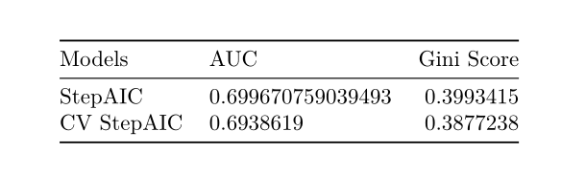

With there being various approaches to modelling credit risk, the current state-of-the-art machine learning models have been dominant in this arena as they are more accurate and efficient. The final model performed better than the old model with a higher Gini value of 0.407 with 85% accuracy, compared to the given Gini value of 0.114 with 85% accuracy.

Traditionally, each bank employs unique scorecards. The important variables from the final model of the project were the term, subgrade, annual income, number of inquiries in the last 6 months, the number of public records, whether the client is employed, loan purpose, revolving utilization rate and the length of the credit. These coincide with the typical variables, with the number of inquiries in the last 6 months, default or bankruptcy record reflected in public record, and loan purpose.

All the procedures throughout this modelling process have been justified by a range of methods. Variables were considered individually were then being removed if it is found statistically insignificant in the full model. This is then being further confirmed using the ANOVA. After obtaining the final model, variable coefficients were analyzed in the context of confidence intervals and business knowledge to confirm that their effects were not ambiguous.